ECA3101-NANO ELECTRONICS
Exp. 6. Demonstration of Quantum Tunneling
TEST CASE-1: transmission co-efficient Vs Energy characteristics
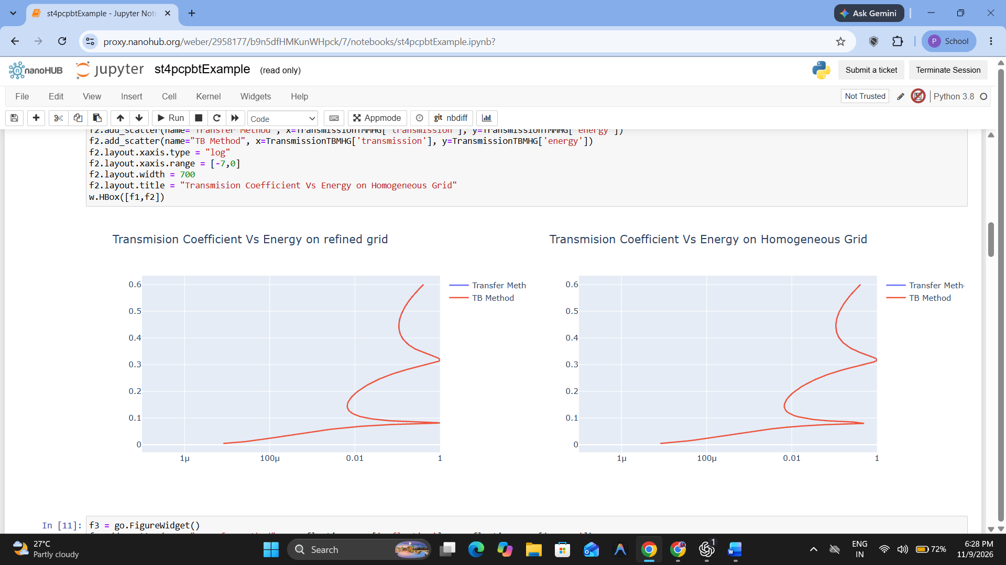
TEST CASE-2: the Reflection co-efficient Vs Energy on Homogeneous Grid


